RESOLUTION NO.__________

RE: CERTIFICATE OF APPROPRIATENESS UNDER THE
PROVISIONS OF THE ACT OF THE PENNSYLVANIA
LEGISLATURE 1961, JUNE 13, P.L. 282 (53
SECTION 8004) AND BETHLEHEM ORDINANCE NO.
3952 AS AMENDED.

WHEREAS, it is proposed to install signs at 333 & 335 S. New Street.

NOW, THEREFORE, BE IT RESOLVED by the Council of the City of Bethlehem that a Certificate of Appropriateness is hereby granted for the work.

Sponsored by: (s)

(s)

ADOPTED BY COUNCIL THIS DAY OF

(s)
President of Council

ATTEST:

(s)
City Clerk

HISTORIC CONSERVATION COMMISSION

CASE # 633– It is proposed to install signs at 333 & 335 S. New Street.
OWNER/APPLICANT: D&P Management/ Ashley Matlock

The Commission upon motion by Ms. Starbuck seconded by Mr. Lauder adopted the proposal that City Council issue a Certificate of Appropriateness for the proposed work described herein:

- The proposal to install signs at 333 & 335 S. New Street was represented by Ashley Matlock.
- The signs will read “Rise Above Hair Studio” in a circle format around a logo in white vinyl installed on the two storefront windows as proposed.
- The smaller window will have an 18” maximum diameter sign in the upper half of the glass; the larger window will have a large sign reduced in size to 30” maximum in diameter, in the center of the glass.
- The motion to approve the proposed work was unanimously approved.

CU: cu
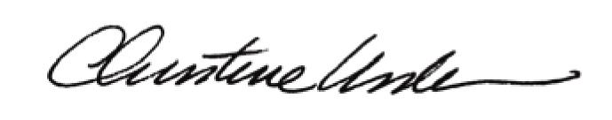

By:

Date of Meeting: November 20, 2017 Title: Historic Officer

